Critical Resoning

https://www.facebook.com/events/543364049360935/543410232689650

[#CR3](https://www.facebook.com/hashtag/cr3?source=feed_text) Sample CR question ideal time : 2 minutes [comments will be off during the time]

In response to the increasing cost of producing energy through traditional means, such as combustion, many utility companies have begun investing in renewable energy sources, chiefly wind and solar power, hoping someday to rely on them completely and thus lower energy costs. These sources require significant initial capital investment, but the operating costs are not so high; so the utility companies claim that they will provide stable energy supplies at low costs. As one can easily see, these sources will be less risky for the utilities than nonrenewable sources, such as gas, oil, and coal, whose prices can fluctuate dramatically according to availability.

The claim of the utility companies assumes which of the following?  
A. The public will embrace the development of wind and solar power.

B. No new deposits of gas, oil, and coal will be discovered in the near future.

C. Weather patterns are consistent and predictable.

D. The necessary technology for conversion to wind and solar power is not more expensive than the technology needed to create energy through combustion.

E. Obtaining energy from non-renewable sources, such as gas, oil and coal, cannot be made less risky.

OA : C

Before we get into the answer let us understand the components of a CR question.

• CR is largely composed of arguments and arguments parts  
• It checks skills of Logical Thinking and Critical Evaluation. One needs eye for detail.

ARGUMENT is the passage that you read.

Argument Parts:  
An argument (passage) generally consists of  
• CONCLUSION(s)  
• SUPPORT TO CONCLUSIONS (Reason, Evidence, Premise, Facts etc.)

Conclusion is what the author tries to establish using facts. Also known as Judgment reached; Opinion, Suggestion, View, Idea, Belief, Proposal, Warning, Forecast, Claim, Stand, Prediction, Hypothesis, POSITION, Stance, Point, Main Point, Inference, Implication, Generalization (about future), Contention, Consequence, Argument, To Posit, etc.

Support to conclusion: also called Fact, Assertion, Evidence, Premise, Proof, Supposition, Data, Information, Research, Consideration, Pattern, Explanation, Justification, Situation, Circumstance, Reasoning, Line of Reasoning, Generalization (about past or present), Judgment in support, Observation, Support, Example, Finding, Phenomenon, Illustration, Reason, To Acknowledge, etc.

These two are stated DIRECTLY in the passage.

Then is assumption which is not stated in the passage

you can think of assumption as anything- be it data, condition, situation, - that the author BELIEVES to be CORRECT.

assumption connects the conclusion and support to conclusion

Argument :

In response to the increasing cost of producing energy through traditional means, such as combustion, many utility companies have begun investing in renewable energy sources, chiefly wind and solar power, hoping someday to rely on them completely and thus lower energy costs.

These sources require significant initial capital investment, but the operating costs are not so high; so the utility companies claim that they will provide stable energy supplies at low costs.

As one can easily see, these sources will be less risky for the utilities than nonrenewable sources, such as gas, oil, and coal, whose prices can fluctuate dramatically according to availability.

The claim of the utility companies assumes which of the following?

CLAIM OF utility companies : These sources require significant initial capital investment, but the operating costs are not so high; so the utility companies claim that they will provide stable energy supplies at low costs.

look at the keywords : STABLE ...energy at LOW OPERATING COST

so there are two assumptions: Renewable energy sources are stable .. and there will be no increase in operating cost later on

A. The public will embrace the development of wind and solar power.

{ WRONG .. public is not in the picture .. we are talking about shifting to renewable source of energy ]

B. No new deposits of gas, oil, and coal will be discovered in the near future.  
[ WRONG. .. even if there are no or abundant deposits.. utility companies STILL ARE hoping someday to rely on RENEWABLE completely and thus lower energy costs. ..so even if deopsits are found .. we are not concerned ]

C. Weather patterns are consistent and predictable.  
[ YES .. weather pattern should be STABLE or CONSISTENT ]

D. The necessary technology for conversion to wind and solar power is not more expensive than the technology needed to create energy through combustion.  
[ WRONG .. we are lookign at OPERATING COST and not conversion cost ]

E. Obtaining energy from non-renewable sources, such as gas, oil and coal, cannot be made less risky.

[ SAME AS B.. it is not about old ways of energy .. but RENEWABLE ways]

Can you give me the CONCLUSION after reading the dialogue between Alauddn and padma ?

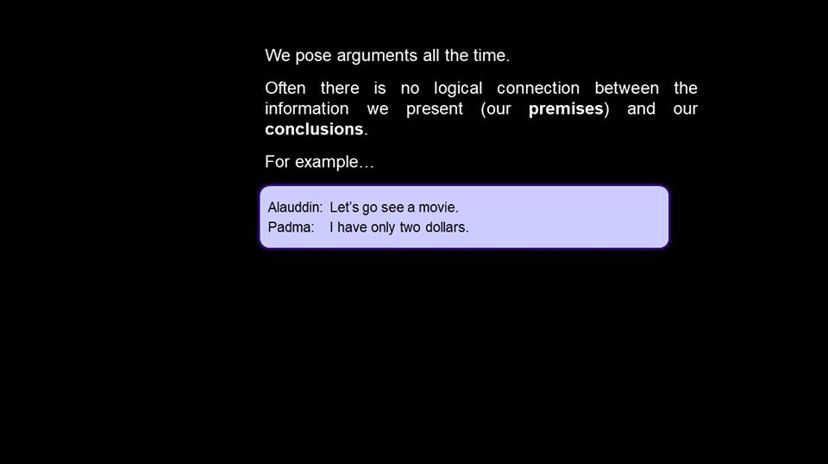

Movie tickets are costlier than 2 dollars.

Answer to [#CR5](https://www.facebook.com/hashtag/cr5?source=feed_text&story_id=543418599355480)

there is NO DEFINITE ANSWER to whether they went to movie or not. There is lot of information that is not stated.   
do we know how much movie ticket costs ? no  
do we know how much money alauddin has ? no   
is it possible that they borrow money from Ratan ( their mutual friend) ? yes .. no

there ARE LOT OF VARIABLES attached to the conclusion. Hence if your concluding anything, you MAYBE taking ASSUMPTIONS.

BEWARE OF 2 things  
1) outside information   
2) assumption you take

[**Aman**](https://www.facebook.com/consultaman?fref=ufi) what will be the best suited conclusion

[Manage](https://www.facebook.com/events/543364049360935/543421246021882/?notif_t=admin_plan_mall_activity&notif_id=1517591094000990)

[Like](https://www.facebook.com/events/543364049360935/543421246021882/?notif_t=admin_plan_mall_activity&notif_id=1517591094000990)

 · [Reply](https://www.facebook.com/events/543364049360935/543421246021882/?notif_t=admin_plan_mall_activity&notif_id=1517591094000990) · [1m](https://www.facebook.com/events/543364049360935/543421246021882/?comment_tracking=%7B%22tn%22%3A%22R%22%7D)

[Rudra Singh](https://www.facebook.com/rudrasingh2220?fref=ufi)

[**Rudra Singh**](https://www.facebook.com/rudrasingh2220?fref=ufi) that a movie is avialable to be watched

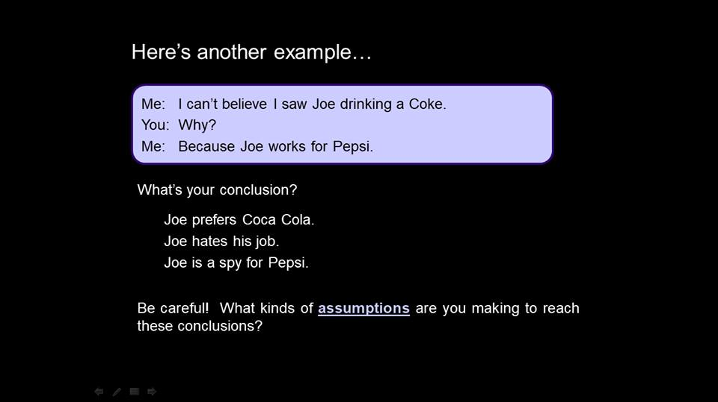

[**Tushar Mehta**](https://www.facebook.com/tushar368?fref=ufi) Coke is a drink and pepsi is some workplace

[1](https://www.facebook.com/ufi/reaction/profile/browser/?ft_ent_identifier=543423172688356_543423419354998&av=100000727300176)

[Manage](https://www.facebook.com/events/543364049360935/543423172688356/?notif_t=admin_plan_mall_activity&notif_id=1517591355707255)

[Like](https://www.facebook.com/events/543364049360935/543423172688356/?notif_t=admin_plan_mall_activity&notif_id=1517591355707255)

 · [Reply](https://www.facebook.com/events/543364049360935/543423172688356/?notif_t=admin_plan_mall_activity&notif_id=1517591355707255) · [1m](https://www.facebook.com/events/543364049360935/permalink/543423172688356/?comment_id=543423419354998&comment_tracking=%7B%22tn%22%3A%22R%22%7D)

[Rudra Singh](https://www.facebook.com/rudrasingh2220?fref=ufi)

[**Rudra Singh**](https://www.facebook.com/rudrasingh2220?fref=ufi) great. that is the best conclusion by anyone in a long time

Joe who works for Pepsi was drinking Coke.

why ?

Maybe he prefers it, maybe Coke was the only drink available, maybe he had money only for Coke, Maybe he wanted to taste it, maybe pepsi has takenover Coke. Maybe his boss scolded him and he in revenge drank Coke.

there are again only ASSUMPTION based answers. so again, WITHOUT ADDING ANY ASSUMPTION, we cannot derive anything.

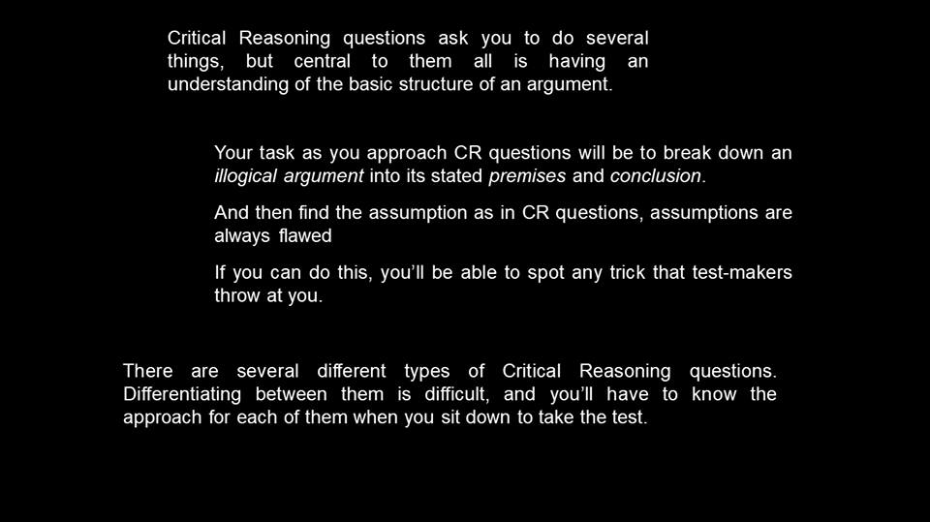

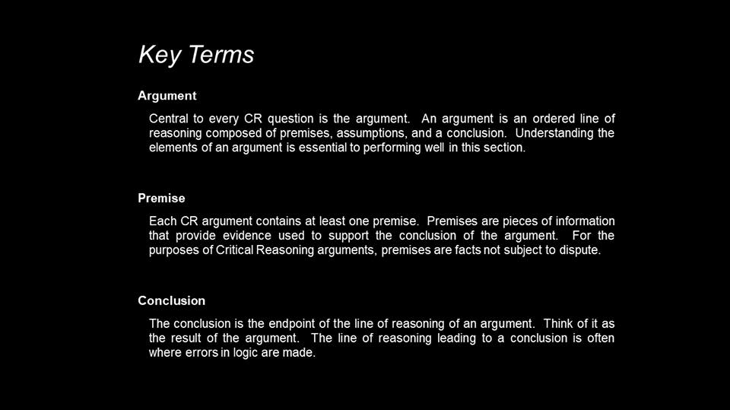

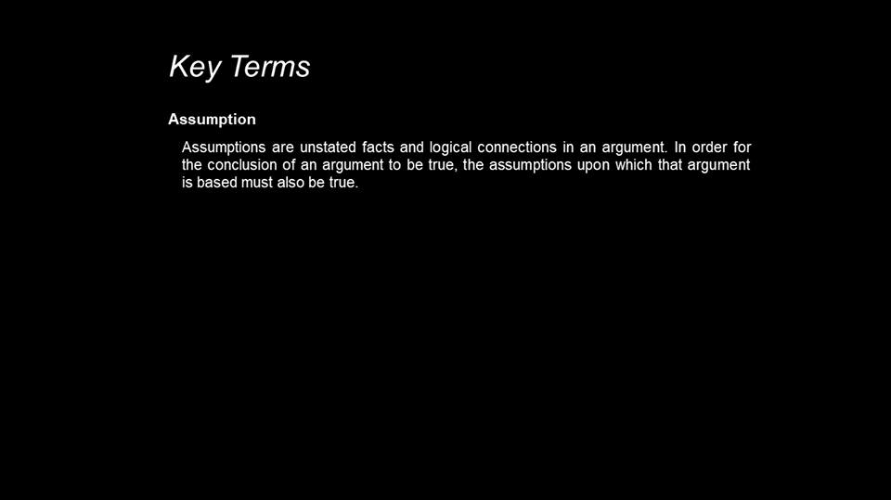

ARGUMENT:

Jeannie studied for the GMAT for four months, and she scored a perfect 800 on it. So, Annette should also study for four months if she is targeting at a perfect 800 on the GMAT.

Conclusion- Annette should also study for four months

Premises- She is targeting at a perfect 800 on the GMAT. Jeannie studied for the GMAT for four months, and she scored a perfect 800 on it.

Assumptions-   
Annette is similar to Jeannie.  
Amount of time decides score.  
Four months enough to get a score of 800.

**All, assumptions are wrong.**

you CANNNOT make assumption in the passage. whether it is RC or CR. ONLY when you are asked a question of assumption, you are supposed to find out the assumption.

Class test 1 time : 10 minutes

Write down the conclusion, premises, and assumptions in the following examples:

2. A recent research shows that CEOs of US based organizations want to add diversity to their organization's  
employee base as it translates into increased competitiveness of the organization. So, all CEOs will increase employment opportunities for members of minority groups in the corporate world.

3. A recent study found that across all age groups, cutting down of fats and carbohydrates intake alleviated symptoms of asthma. Therefore, decrease in intake of carbohydrates and fats can be an effective nonpharmacological approach to treating asthma.

4. A scientist found that all those who suffer from migraine drink more than four cups of coffee a day. So the scientist suggested that completely avoiding coffee can solve the migraine problem.

5. The only effective cure for migraine is a balm prepared according to the Chinese system of medicine from skull  
bones of the Siberian tiger. The Siberian tiger is an endangered species and as the demand for the balm is very high, conservationists fear that continued production of the balm will lead to extinction of Siberian tigers.

6. A proposed change to federal income tax laws would eliminate deductions from taxable income for donations a taxpayer has made to charitable NGOs involved in increasing the employability of minority groups. If this change were adopted, wealthy individuals would no longer be permitted such deductions. Therefore, many NGOs would have to reduce services, and some would have to close their doors.

My answers:

2

conclusion : CEOs will increase employment opportunities for minority groups.

premise: research shows diversity translates into increased competitiveness

assumption: minority groups are not getting equal opportunities right now.

3

c: decrease carbs and fats to treat asthma

p: research showed cutting down carbs and fats reduced symptoms of asthma

a: carbs and fats intake is the only reason for asthma

4

c: avoid coffee to solve migrane

p: more than 4 coffee cause migrane

a: coffee is primary reason for migrane

5

c: increasing use of balm may lead to tigers extinction

p: tiger bones balm effective cure for medicine

a: tiger balm the only cure for medicine.

6

c: if donations are made taxable NGOs functioning and funding will be impacted

p: proposed change in federal income tax laws

a: NGOs receive most of the funding only from wealthy individuals.

answers:

Remember folks, your WORDS maybe different, but the answers should reflect similar idea

2.  
Conclusion - All CEOs will increase employment opportunities for members of minority groups in the corporate world.

Premises- A recent research shows that CEOs of US based organizations want to add diversity to their organization’s employee base as it translates into increased competitiveness of the organization.

Assumptions-   
CEOs of US based organizations represent all CEOs  
Minorities add diversity  
CEOs will be able to do what they want

3.  
Conclusion- Decrease in intake of carbohydrates and fats can be an effective non-pharmacological approach to treating asthma.

Premises- Across all age groups, cutting down of fats and carbohydrates intake alleviated symptoms of asthma.

Assumptions-   
Treating the symptoms of asthma is equivalent to treating it.  
Nothing else except decrease in intake of carbohydrates and fats can be an effective non–pharmacological approach to treating asthma.

4.  
Conclusion- Completely avoiding coffee can solve the migraine problem  
Premises- All those who suffer from migraine drink more than four cups of coffee a day.  
Assumptions- Nothing else except coffee leads to migraine  
Migraine does not cause people to drink more coffee.

5.  
Conclusion – Continued production of the balm will lead to extinction of Siberian tigers.  
Premise – The only effective cure for migraine is a balm prepared according to the Chinese system of  
medicine from skull bones of the Siberian tiger. The Siberian tiger is an endangered species.

Assumptions –   
Removing the skull bones leads to death of Siberian tiger.   
The birth rate of Siberian tiger cannot be increased artificially. Nothing else except skull bones of tiger can be used to prepare  
the balm.   
Nothing else except the balm can cure migraine

6.  
Conclusion – Many NGOs would have to reduce services, and some would have to close their doors.

Premise – A proposed change to federal income tax laws would eliminate deductions from taxable income for donations a taxpayer has made to charitable NGOs involved in increasing the employability of minority groups. If this change were adopted, wealthy individuals would no longer be permitted  
such deductions.

Assumptions –   
Donations by wealthy individuals made for tax deductions are an important part of donations made to NGOs.   
Charitable NGOs involved in increasing the employability of minority groups represent all NGOs  
Donations are the only source of income of NGOs

A scientist found that all those who suffer from migraine drink more than four cups of coffee a day. So the scientist suggested that completely avoiding coffee can solve the migraine problem.

now this is what is called CAUSAL assumption.   
there are 4 major types of assumptions taken by author

1) Causal.. the author sees two events, actions, phenomena happenind together and will conclude that since X and Y are happening together, one of them caused the other to happen. and that there is ONLY one cause for the outcome to happen

for example

Padmavat movie was launched in January and in February, the government presented its Union budget. So Padmwavat movie resulted in presentation of the Union Budget.

is this a valid conclusion ?

No.

in causal assumption we also assume the order of cause and effect.

For example  
Whenever I am tired, I become lazy. So my laziness is caused by my being tired.

I am assuming that I am LAZY because I am tired. this means I am assuming that laziness is the outcome and tiredness is the cause

Is it possible that I am Lazy that is why I am tired. I mean to say is it possible that is is possible that I get tired because I am lazy ?  
YES. the statement mentioned that two things happen together. does it mention the order of hte events? no   
I assumed that first is the cause and second is the outcome

it is failry possible that tiredness is the outcome and laziness the cause

CAUSAL FLAW also assumes tht there is ONLY ONE CAUSE for the event to take place.. or only ONE CAUSE for EFFECT

class extended by 20 mins   
[ need to cover all the flaws ]

analogy flaw

the author will compare two things, people. he will take the caes of one person and then give the conclusion of other person.

Like   
Jeanie, a girl, prepared for GMAT in 4 months and scored 800. So Subhadra, another GIRL, should also prepare in 4 months and then she will also score 800..

is this right? no

the author ASSUMES that since both are girls, they will behave the same

 this is called analogy flaw. analogy means comparing two people or things and finding relation between them

For an analogy flaw, linking should be provided in the argument.

eg: It is popular belief that students of 12th standard study better while listening to music. Therefore CAT students also should listen to music while solving RC.

find the flaw

[**Tushar Mehta**](https://www.facebook.com/tushar368?fref=ufi) 12th standard and cat student will behave in same manner https://static.xx.fbcdn.net/images/emoji.php/v9/f51/1/16/1f603.png:D https://static.xx.fbcdn.net/images/emoji.php/v9/f51/1/16/1f603.png:D

[1](https://www.facebook.com/ufi/reaction/profile/browser/?ft_ent_identifier=543461626017844_543461829351157&av=100000727300176)

[Manage](https://www.facebook.com/events/543364049360935/permalink/543461626017844/?notif_t=event_mall_reply&notif_id=1517597253819854)

[Like](https://www.facebook.com/events/543364049360935/permalink/543461626017844/?notif_t=event_mall_reply&notif_id=1517597253819854)

 · [Reply](https://www.facebook.com/events/543364049360935/permalink/543461626017844/?notif_t=event_mall_reply&notif_id=1517597253819854) · [1m](https://www.facebook.com/events/543364049360935/permalink/543461626017844/?comment_id=543461829351157&comment_tracking=%7B%22tn%22%3A%22R1%22%7D)

[Sagar Tavse](https://www.facebook.com/sagar.tavse?fref=ufi)

[**Sagar Tavse**](https://www.facebook.com/sagar.tavse?fref=ufi) CAT student and 12th student have same learnings to perform. analogy flaw

[#CR16](https://www.facebook.com/hashtag/cr16?source=feed_text) Statistical flaw is made when the author presents incomplete data [ Amity is the best university for MBA in India as per ET rankings ] or distorted Data

for example

Ninety percent of the population of Prelandia lived in rural areas in 1800. Today, only 20 percent of the population lives in rural areas. Clearly, more people lived in the countryside two  
centuries ago.

is the above conclusion about PRelandia's populations correct ?

 no.. percentages don't reflect actual amounts.

 LAST post and last flaw.. SAMPLE.. in this ..author will conclude from a sample or a review. but then the assumption will be that the sample is valid ..both quantitaively and unbiased

Contrary to popular belief, high school students overwhelmingly approve of the high school administrative staff. We know this to  
be true because the student council expressed admiration for the high school principal and her staff in the council’s editorial for the school paper.

so can we conclude that SCHOOL STUDENTS approve of staff ?

No.... This is specification and not generalization.